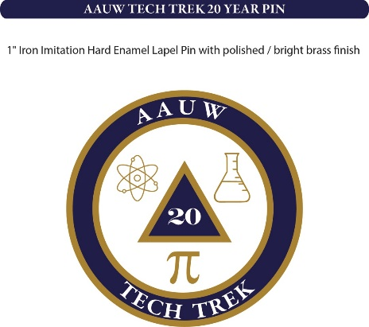

Tech Trek Fundraiser 20 Year Pins

Order Form

Name: _________________________________________________

Street Address: ______________________________________________

City: __________________________________________ State: _______

Phone: ____________________________

Number of Pins at $5.00 per pin: ___________________

Total Amount Included: $_________________________

Send Completed Form with Check or Money Order made out to:

AAUW Simi Valley

!95 Tierra Rejada Rd # 111

Simi Valley, CA 93065

